**Step 1:** Logged in to AWS Console and selected EC2 Service.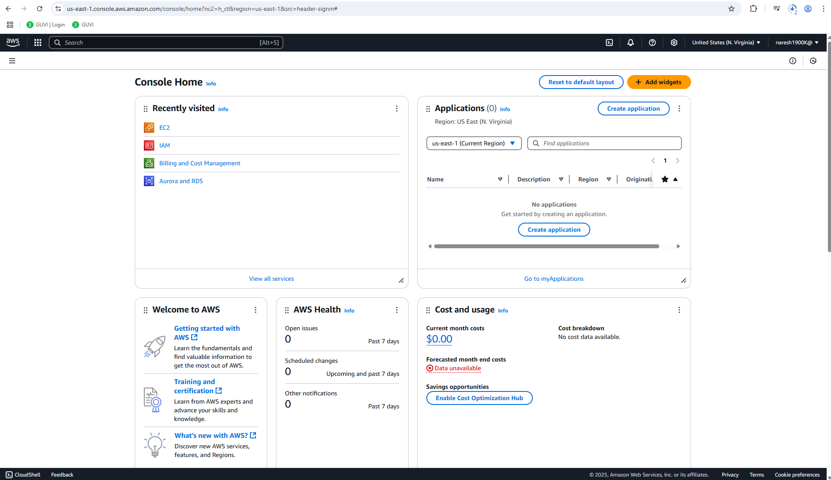

**Step 2:** Clicked on Launch Instance button

**Step 3:** Fill up the required details.

PEM file downloaded



Instance has been created

**Step 4:** Navigated to RDP client tab to retrieve the password before launching RDP in windows

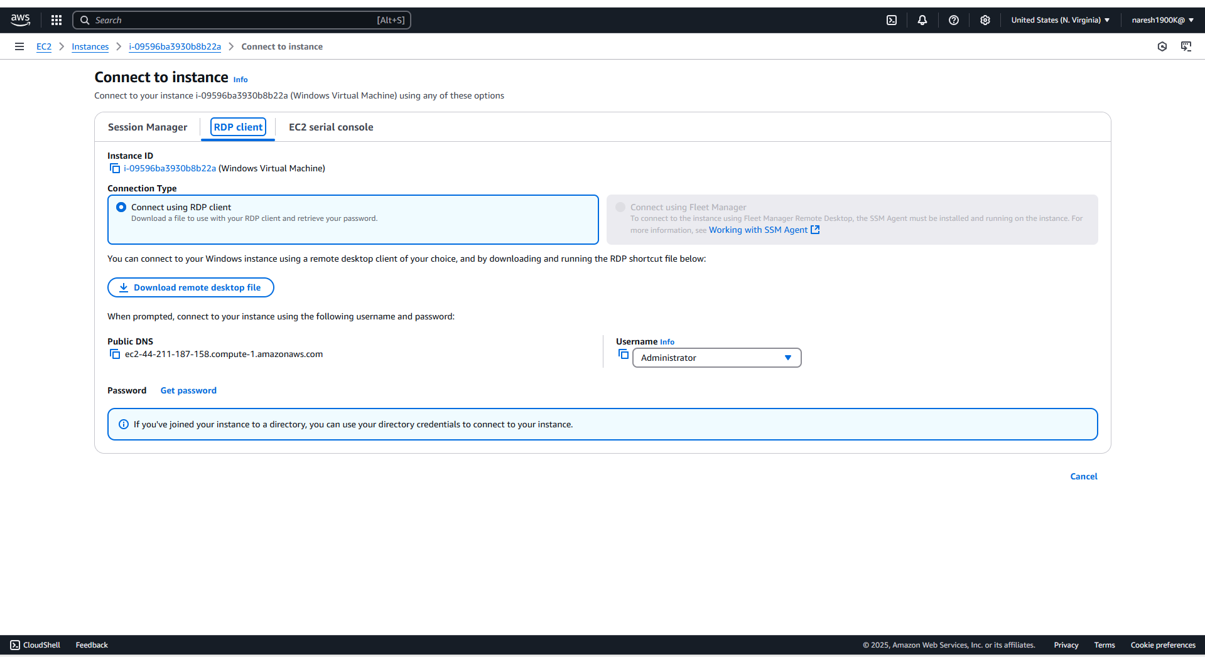

Password Retrieved

**Step 5:** Download the RDP file, opened Remote Desktop on my Windows machine, and then upload the RDP file into the Remote Desktop application.

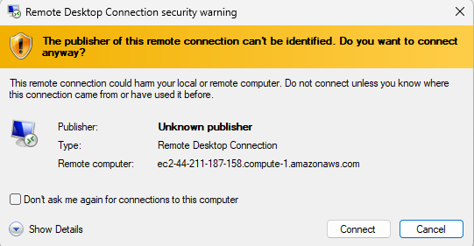

System Info

